Day 5 tasks:

Session 1:

Selenium Automation with Python:

Installed Selenium and Chrome WebDriver.

Walked through a simple Selenium automation script:

from selenium import webdriver

driver = webdriver.Chrome()

driver.get("https://qxf2.com/selenium-tutorial-main")

name = driver.find_element(by="id", value="name")

name.send_keys("Qxf2")

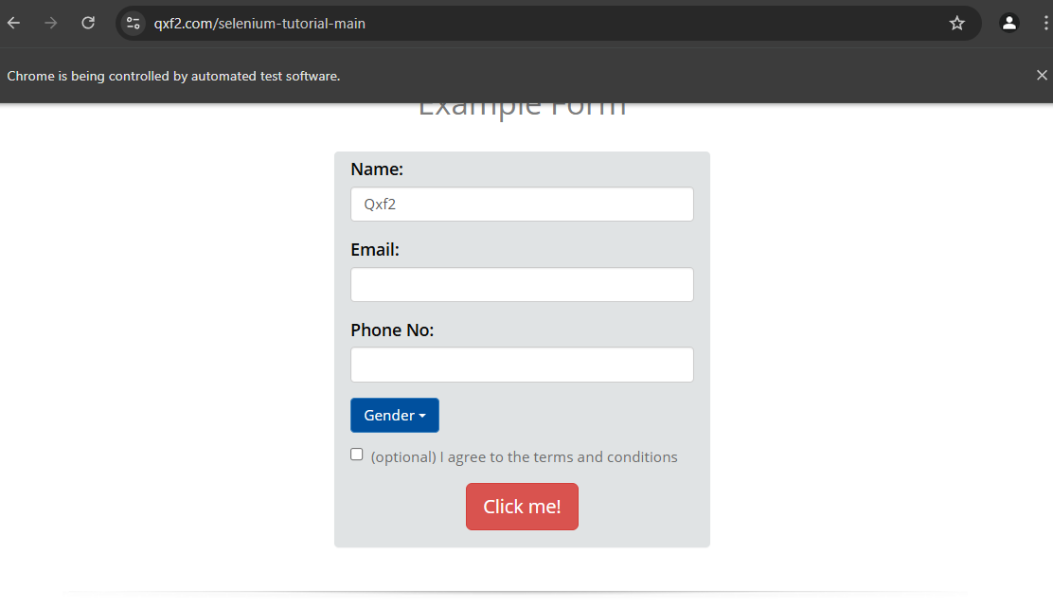

Session 2:

1)API Testing Using Postman.

Introduced API testing fundamentals.

Demonstrated sending GET and POST requests and validating responses.

2)API Testing with Python Requests Library

Explained API testing using Python’s requests module.

Executed API calls to a local server (<http://127.0.0.1:5000/>).

